CS50's Introduction to Computer Science
https://www.edx.org/learn/computer-science/harvard-university-cs50-s-introduction-to-computer-science?index=product&queryID=608a33fbd2815c84cea7392e442e50ff&position=1&results_level=first-level-results&term=cs50&objectID=course-da1b2400-322b-459b-97b0-0c

PROGRAM FLOW;
1. Introduction to scratch
2. Programming languages (c)
3. Python
4. Databases
5. Markup languages (HTML)
6. Frameworks
7. Puzzle day
8. Capstone

Computer science;
This is the study of information and use the information to solve a problem.
Basically computers use the binary representation of the data.
Computers have access to only electricity as their inputs. Therefore they use this electricity manipulations states to get smart. In computers, each transistor has only two possible states of electricity (ON & OFF). In human understanding, the two states can be treated as numbers and the best tallying base count is a binary base.
A bit is a binary digit.
A byte is comprised of eight bits
ASCII- American Standard Code for Information Interchange;
this is the standard system used to map letters to binary representations eg. 65 is mapped as letter A; AND it turns out to be represented as 10000001 in binary representation of the computer.

Unicode ;; this is a more organized and broad standard that is used to represent all characters, emoji and many more symbols on a computer. For Unicode, most of the symbols in all languages are captured and standardized for the sake of standard representation of the same symbol.
Unicode utilize 32bits operation to capture all possibilities of the combinations of zeros and ones to mean something on a computer,( in the binary form). In this system of 32bits, there are 32! possibilities of representation of symbols.
With Unicode, representation of emoji of different colors is made possible by fixing a unique set of characters out of the 32 digits, then alter the other characters to represent the color of the emoji. In the same way, representation of joint emojis is made possible by Unicode,
Images;
computers represent images using pixels on screens. Each pixel receives a number that represents the amount of red, green and blue to represent. Each symbol and emoji using the 32 bits representation has a combination of digits that represent the amount of rgb in it. Photo-shop and other picture related programs will read these digits and know which color to represent at a moment. For each symbol that is using 32 bit representation, there are 3 bits allocated for this work. Each bit taking numbers up to 256 ie the highest number representative by a bit.
Videos;
For the sake of videos, computers represent videos by displaying rapidly changing images. For a human being, the representation will give a something display thus showing a video. Therefore videos are sequences of images.
Music
For music, the music notes are digitalized by giving each frequency, pitch and other variables different and unique digital numbers. Mp3, MP4 and other extensions of music represent other standardization of music notes.
COMPUTER ALGORITHMS
Computer algorithm is the way computer work upon a certain problem. Computer algorithms are so fast since they use the process of bisecting the challenge until it remains with two possibilities then finally choose the right and final possibility.

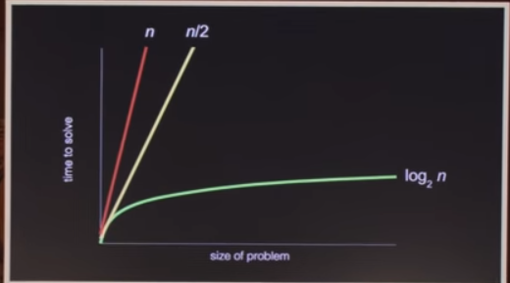

The picture below shows the general way of computers solving a certain problem
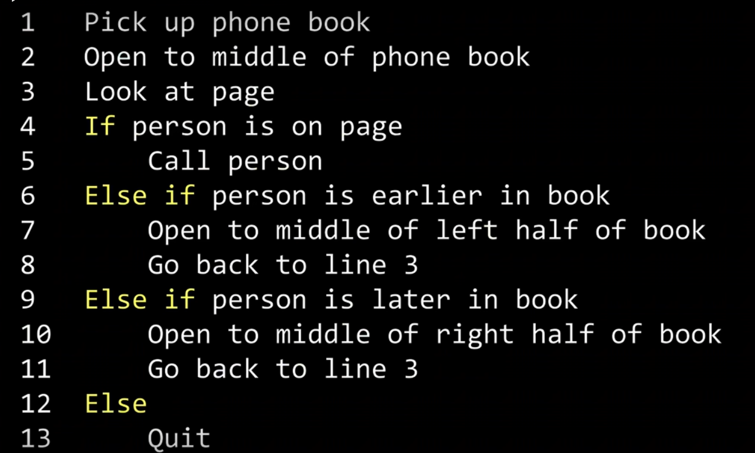

The picture below shows the general primitives of solving problems using computers

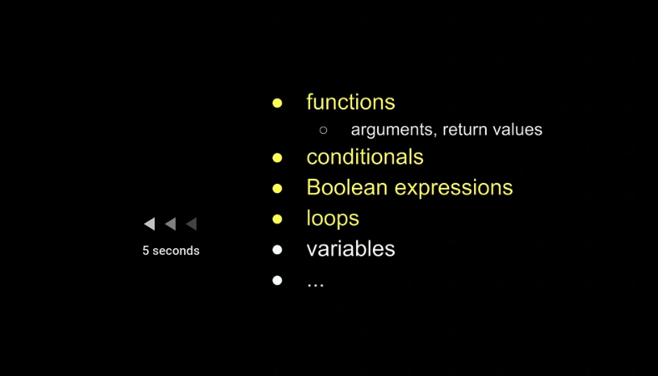

C language;
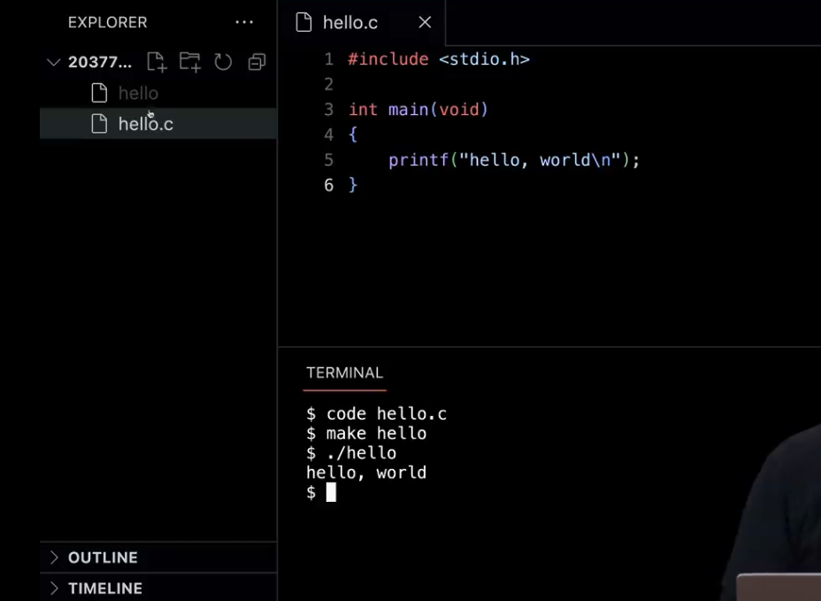

C is the co is the core programming language that can be learned first and make the learning of all the other programming languages easy.
In the above code. $ code hello.c creates a new file that is in the c languages
$ make hello ; this line makes the program called hello
$ ./hello runs the program hello which is found in the directory ./hello
header files are the lines of code that call different libraries. In the above code, we have the first line calling the files declareing the functions like printf and many more. Manuals give detailed information about the existing files and functions in a library.
Manual.cs50.io/#stdio.h gives the list of all the functions included in the header file of the above code.
The picture below shows some of the functions we are talking about

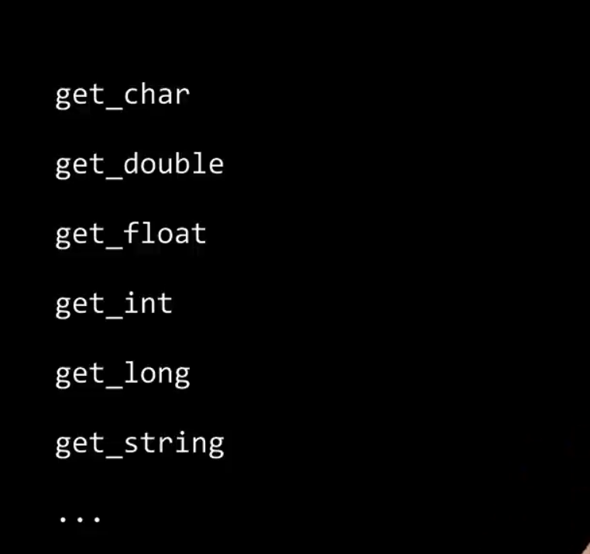

One of the most used inbuilt functions in c is the printf
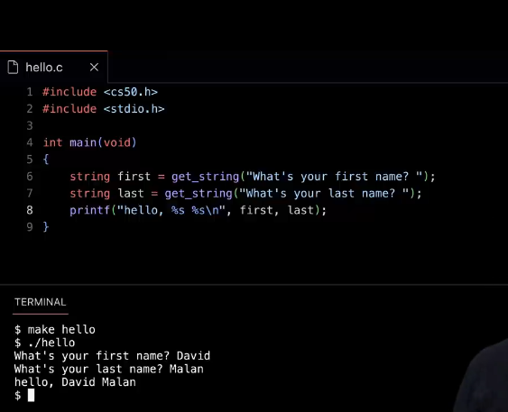
It is used to display content on the screen. Eg

in the above figure, the % is the place holder for the value that is already assigned lately, ‘s’ is the nature of the value that is going to be attached in the place of the place holder, \n is the symbol that allows the prompt to go to the next line after executing the above

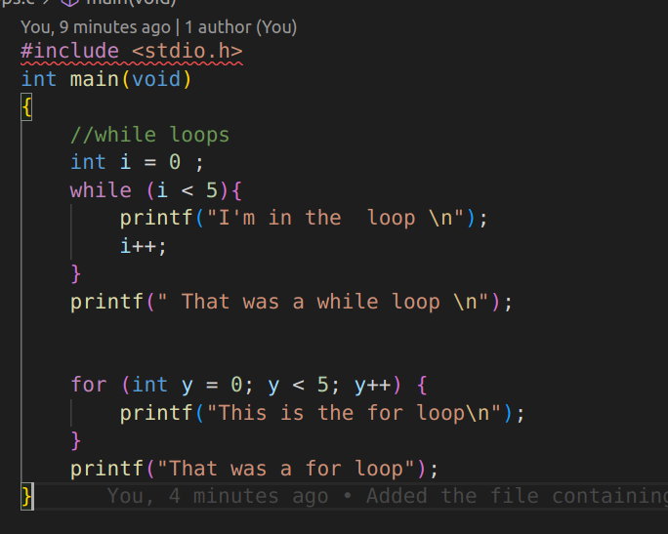

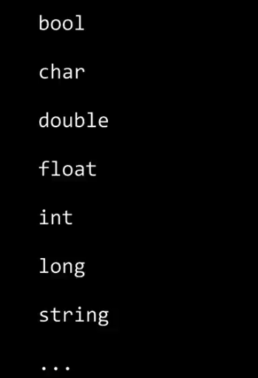Figure 1: data types

Loops in c language
we have both for loops and the while loops . Below is the picture showing how each of them can be used

COMPILING IN C LANGUAGE;
we have many different compilers in c language , the main and the oldest compiler is called clang; Below is the picture that shows how to use it. Note; The clang compiler gives the command line actions that can rename the default program name that is made after compiling the program. Nb; the default name of the compiled code is ‘’’’ a.out’’’ standing for assembly output.
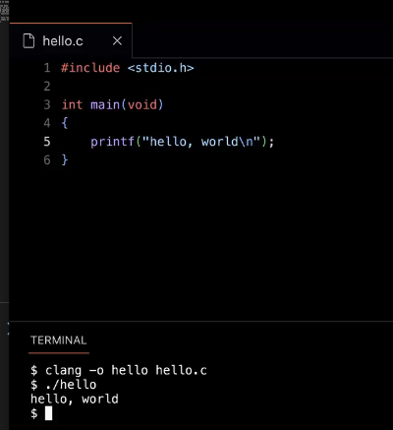

In the above code, ‘-o’ will rename the output code as hello from the original file called hello.c
in case we use the third party libraries, we need to link the libraries to the compiler as below. The argument lcs50 links the libraries to out compiled code.
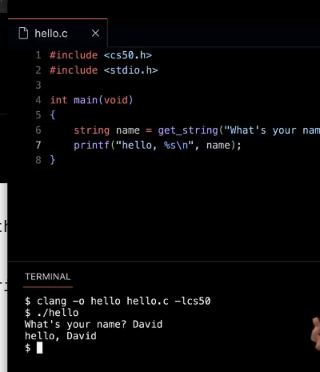

Processes of compiling the program;
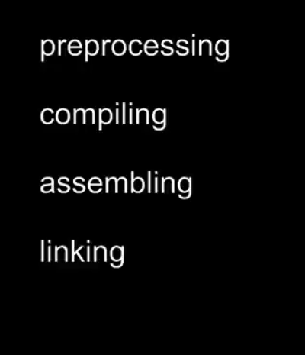

P reprocessing; Here the compiler just process the whole code starting with the code lines having ‘#’ . # is a symbol that tells the compiler that this line should be processed earlier.
Compiling; this step happens after reprocessing where the code is translated to assembly code. Assembly code is the code that is directly understood by the CPU of the computer. It contains unit instructions based on single operations per line of code. This code base on the simple mathematics and simple operations like removing and adding things to accomplish the tasks of the complied code.
Assembling; This is the step where the assembly code is translated to the machine code. The machine code is the code of zeros and ones.
Linking; This step links the libraries and other external actions to the machine code. This is the last step where all necessary links to the code are put in one place.

DEBUGGING;
In vs code we have a debugger that comes as the in built program. This debugger is called the buggy tools. Bellow it eh pic that show how we can use the buggy tool. Before launching the buggy tool, you need to make a break point where you think an error is in the code, This is done by clicking on the left end of the line of interest ( Click on the left red dot that gets highlighted when you hover over the left margin of the line of interest.). after that step, you run the command (‘ debug50 ./buggyo’) ./buggy0 is the compiled file. (you need to compile the code first)
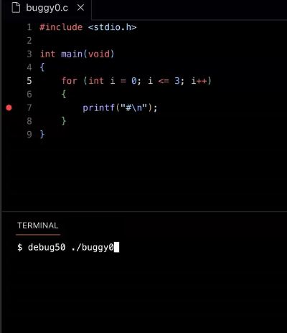
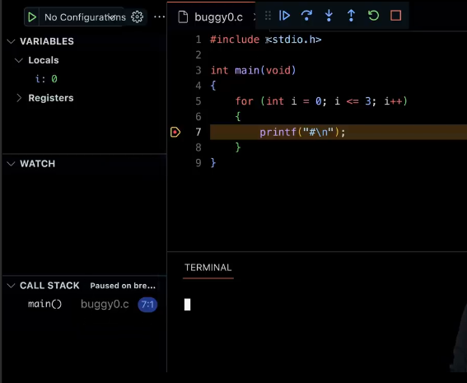

We use the play buttons at the top of the vs code to run the code in the desired pattern so that you can see the error in the code.
ARRAYS;
these are used to represent data and store it in one place. This makes it easy for the computer to find anything in the array
arrays are declared using the main code below;
> int array[5]; this means that the array named ‘array ‘ will take integers and will have 5 places in it. Bellow is an example code of array manipulation in C languages

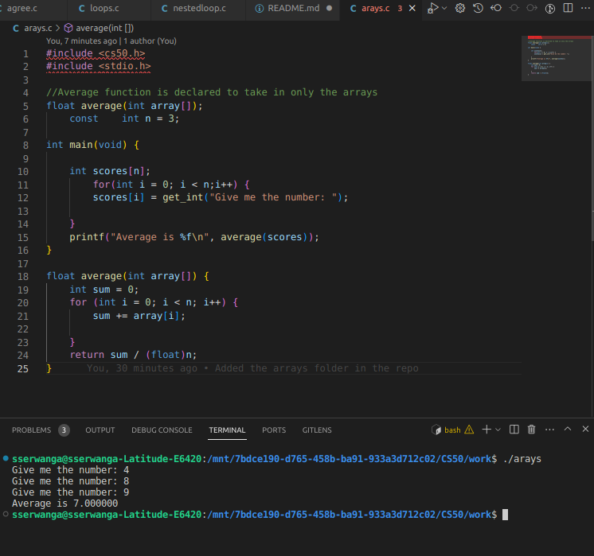

LIBRARIES;
In c language, we have several libraries that we can use to implement more complicated programs. These libraries have built several short functions and programs that we use in our codes to get large and tasks that would have been complicated easy. Examples of the libraries we have; ctype library which give us access to the functions that manipulates the strings and we also have the string library that can give us access to functions like ‘strlen’ which give us the length of the string provided to it ,

COMMAND LINE ARGUMENTS;
These are the inputs for the command line.
This is demotrated mainly in the int main function which happens to be the main function of the c programs. These comand line arguments used in the int main() function gives the user the abilities to input the arguments of the program immediately after the program is called but before runing it. For example;
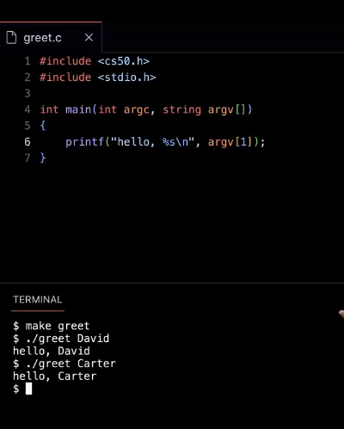
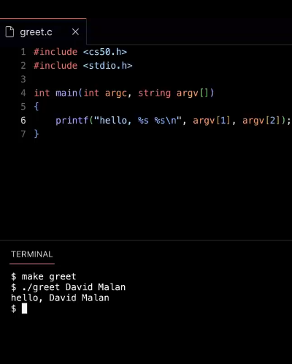
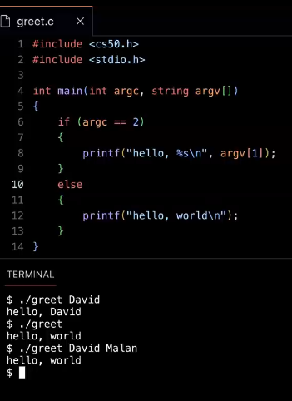

In the above code, the arguments in the int main(int argc, string argv[]); -int argc stands for argument count which gives the main function the number of arguments provided for the programs
- string argv[] means that the ‘argument value’ and in the above case it is the array of strings.
- argv[] stands for the variable in the second position of the array of arguments.
Note; The argv[0] place is taken by the name of the program.
- ‘int’ means that the output of the main function will be the integer. These integers are always not printed on the screen but they be underneath the screen. These integers are called the exit status statuses. In c language the exit status of the main function is set to be 0 by default.
The exit statuses of the function can be manipulated to be something else depending on the condition of the program execution. This can help the programmer to know where the error is in the program.
- Void in the int main(void) function shows that the function is taking in not command line arguments

ALGORITHMS
These are set of principals that the program follows to execute.
We have different algorithms to solve deferent problems, the main algorithms we have are namely;
- linear algorithms
- logarithmic algorithms
- quadratic algorithms and many more
The application of the algorithms in any operation can give different efficiency depending on the type of operation, therefore, we choose the algorithms to use for a certain operation after weighing all the possibilities that can come out of the use of all algorithms and then after we chose the algorithm that will do the task in the shortest time possible.
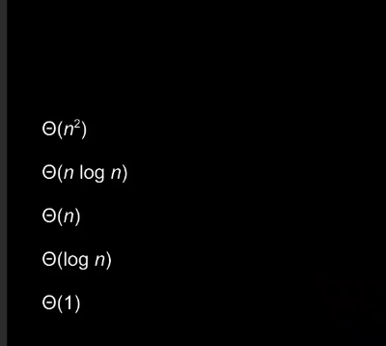Figure 2: types of algorithms

P
PYTHON LANGUAGE/
this Is one of the most mordern programing languages in the programing world. It provides many of the work already inbuilt in it so that the user do not waste a lot of time coding everything from scratch like the way c language does it. For example in python the user does not have to worry about memory allocations and management. This work is already beind done by the python developers to save the users time.
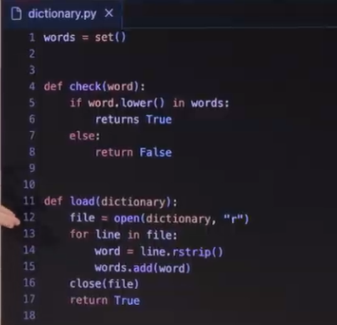
Below is the example of the dictionary designed in python. This program checks for the presence of the word in the list of words.

Another example of python coding is here where we use the if else conditions

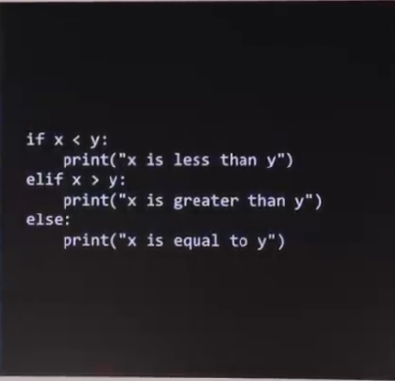

coding common building blocks in python;
variables;
x = ………………
here , you don’t need the semi colon at the end of the line , you don’t need to specify the data type of the variable.
Adding one on the variable;
x+=
x-=
loops;
while loop;
I =0
while I < 3
print(‘hello to you’)
for loop;
for in [0, 1, 2]
print(“hello to you”]
or
for range(3):
print(“hello to you”)
this use the function called range; this Is a data type in python. It specifies the range of the times you want something to happen.

